**FULL STACK - 2**

**(2020-21)**

**MEMORIES**

**Project Report**

Department of Computer Engineering & Applications **Institute of Engineering & Technology**



**GLA University**

**Mathura- 281406, INDIA**

**Supervised By :- Mr Pankaj Kapoor**

**Submitted By :– Aditi Agrawal (181500040)**

**Mayank Goyal (181500376)**

**Declaration**

We hereby declare that the work which is being presented in the Project **“Memories”,** in partial fulfillment of the requirements for Fullstack project is an authentic record of our own work carried under the supervision of **Mr. Pankaj Kapoor**

**Mayank Goyal**

**Aditi Agrawal**

**Table of Contents**

**ACKNOWLEDGEMENT 4 ABSTRACT 5**

**INTRODUCTION 6**

**Motivation 7**

**Problem Statement 8**

**Objective 9**

**TECHNOLOGIES USED 10**

**MERN Stack 10**

**What is Mern Stack ? 10**

**MongoDB 11**

**Express JS 13**

**React JS 14**

**Node.js 15**

**SOME OTHER TECHNOLOGIES USED 17**

**HTML 17**

**CSS 18**

**JavaScript 19**

**REDUX 20**

**Principles of Redux 20**

**Redux Integration With Redux 21**

**Redux Workflow 21**

**HARDWARE REQUIREMENTS AND SOFTWARES USED 23**

**SUMMARY OF MODULES/PAGES 24**

**ACKNOWLEDGEMENT**

We take this opportunity to acknowledge all the people who have helped us wholeheartedly in every stage of this project.

I also extend our sincere thanks to all other faculty members of the Computer Science & Engineering Department.

Last but not the least, we acknowledge our friends for their contribution in the completion of the project

**ABSTRACT**

This project is to make a full stack web application based on MERN technology which will help users make cards of their memories. The App is called "Memories" and it is a simple social media MERN application that allows users to post interesting events that happened in their lives.

**INTRODUCTION**

Memories- A social media application. It helps people to share their experiences or we can say memories which may happened once in life.

It is a social application through which people can get the experiences of other and plan as per their interest.

This application basically save all the memories for life time so any one can read it anytime.

**Motivation**

Now a days our photo galleries have become filled with our daily lives experiences or we can say with what are almost like disposable memories. We snap and share, but then never return and reminisce. So we have planned to create a application which is Memories- A social media application. It helps people to share their experiences or we can say memories which may happened once in life.

It is a social application through which people can get the experiences of other and plan as per their interest.

This application basically save all the memories for life time so any one can read it anytime.

**Problem Statement**

Our photo galleries have become filled with our daily lives experiences or we can say with what are almost like disposable memories. We snap and share, but then never return and reminisce. So we have planned to create a application which is Memories- A social media application. It helps people to share their experiences or we can say memories which may happened once in life.

**Objective**

Objective of this project is to make a full stack web application based on

MERN technology which will help users to share their experiences

(can add image, tags, message, like it aur delete it)

**TECHNOLOGIES USED**

**MERN Stack**

**What is Mern Stack ?**

MERN Stack is a Javascript Stack

that is used for easier and faster deployment of

full-stack web applications. MERN Stack comprises 

4 technologies namely: MongoDB, Express, React

and Node.js. It is designed to make the development

process smoother and easier. Each of these 4 powerful

technologies provides an end-to-end framework for

The developers to working and each of these technologies

play a big part in the development of web applications

MongoDB

MongoDB is a NoSQL database where each record is a document consisting of key-value pairs that are similar to JSON (JavaScript Object Notation) objects. MongoDB is flexible and allows its users to create schema, databases, tables, etc. Documents that are identifiable by a primary key make up the basic unit of MongoDB. Once MongoDB is installed, users can make use of Mongo Shell as well. Mongo shell provides a JavaScript interface through which the users can interact and carry out operations (eg: querying, updating records, deleting records.

**Advantages of MongoDB**

● Fast – Being a document-oriented database, easy to index documents. Therefore a faster response.

● Scalability – Large data can be handled by dividing it into several machines.

● Use of JavaScript – MongoDB uses JavaScript which is the biggest advantage.

● Schema Less – Any type of data in a separate document. ● Data stored in the form of JSON –

1. Objects, Object Members, Arrays, Values and Strings

2. JSON syntax is very easy to use.

3. JSON has a wide range of browser compatibility.

4. Sharing Data: Data of any size and type(video, audio) can be shared easily.

● Simple Environment Setup – It's really simple to set up MongoDB.

● Flexible Document Model – MongoDB supports document-model(tables, schemas, columns & SQL) which is faster and easier.

● Creating a database: Simply done using a ​**“use”​** command: 10

Express JS

Express is a Node.js framework. Rather than writing the code using Node.js and creating loads of Node modules, Express makes it simpler and easier to write the back-end code. Express helps in designing great web applications and APIs. Express supports many middlewares which makes the code shorter and easier to write

**Advantages Of Express JS**

● Asynchronous and Single-threaded.

● Efficient, fast & scalable

● Has the biggest community for Node.js

● Express promotes code reusability with its built-in router.

● Robust API

● Create a new folder to start your express project and type below command in the command prompt to initialize a package.json file. Accept the default settings and continue.

React JS

React is a JavaScript library that is used for building user interfaces. React is used for the development of single-page applications and mobile applications because of its ability to handle rapidly changing data. React allows users to code in JavasScript and create UI components

**Advantages of React**

● Virtual DOM – A virtual DOM object is a representation of a DOM object. Virtual DOM is actually a copy of the original DOM. Any modification in the web application causes the entire UI to re-render the virtual DOM. Then the difference between the original DOM and this virtual DOM is compared and the changes are made accordingly to the original DOM.

● JSX – Stands for JavaScript XML. It is an HTML/XML JavaScript Extension which is used in React. Makes it easier and simpler to write React components.

● Components – ReactJS supports Components. Components are the building blocks of UI wherein each component has a logic and contributes to the overall UI. These components also promote code reusability and make the overall web application easier to understand.

● High Performance – Features like Virtual DOM, JSX and Components makes it much faster than the rest of the frameworks out there.

● Developing Android/Ios Apps – With React Native you can easily code Android-based or IOS-Based apps with just the knowledge of JavaScript and ReactJS.

● You can start your react application by first installing “create-react-app” using npm or yarn.

Node.js

Node.js provides a JavaScript Environment which allows the user to run their code on the server (outside the browser). Node pack manager i.e. npm allows the user to choose from thousands of free packages (node modules) to download.

**Advantages Of Node.js**

● Open source JavaScript Runtime Environment

● Single threading – Follows a single threaded model.

● Data Streaming

● Fast – Built on Google Chrome’s JavaScript Engine, Node.js has a fast code execution.

● Highly Scalable

● Initialize a Node.js application by typing running the below command in the command window. Accept the standard settings.

“​*npm init”*

**Why MERN Stack ?**

● The speed of design and development of websites and web applications, ● Reducing server costs,

● The performance of greatly optimized web applications and software,

● The ease of transposing a web application to a mobile application or software, thanks in particular to React Native,

● The luxury of designing a website using a single HTML document, 13

● The development of a computer application using a single language, JavaScript.

**SOME OTHER TECHNOLOGIES USED**

HTML

Hypertext Markup Language (HTML) is the standard markup language for documents designed to be displayed in a web browser. It can be assisted by technologies such as Cascading Style Sheets (CSS) and scripting languages such as JavaScript**.**

Web browsers receive HTML documents from a web server or from local storage and render the documents into multimedia web pages. HTML describes the structure of a web page semantically and originally included cues for the appearance of the document.

HTML elements are the building blocks of HTML pages. With HTML constructs, images and other objects such as interactive forms may be embedded into the rendered page. HTML provides a means to create structured documents by denoting structural semantics for text such as headings, paragraphs, lists, links, quotes and other items. HTML elements are delineated by tags, written using angle brackets. Tags such as <img /> and <input /> directly introduce content into the page. Other tags such as <p> surround and provide information about document text and may include other tags as sub-elements. Browsers do not display the HTML tags, but use them to interpret the content of the page.

HTML can embed programs written in a scripting language such as JavaScript, which affects the behavior and content of web pages. Inclusion of CSS defines the look and layout of content. The World Wide Web Consortium (W3C), former maintainer of the HTML and current maintainer of the CSS standards, has encouraged the use of CSS over explicit presentational HTML since 1997

**The JSX components in our Application also returns HTML as the final output**

CSS

**C**ascading **S**tyle **S**heets, fondly referred to as CSS, is a simple design language intended to simplify the process of making web pages presentable.

CSS handles the look and feel part of a web page. Using CSS, you can control the color of the text, the style of fonts, the spacing between paragraphs, how columns are sized and laid out, what background images or colors are used, layout designs,variations in display for different devices and screen sizes as well as a variety of other effects.

CSS is easy to learn and understand but it provides powerful control over the presentation of an HTML document. Most commonly, CSS is combined with the markup languages HTML or XHTML.

JavaScript

JavaScript is the **base technology** of our whole project. Whole Backend as well as some part frontend is developed using Javascript

JavaScript often abbreviated as JS, is a high-level, interpreted programming language that conforms to the ECMAScript specification. It is a programming language that is characterized as dynamic, weakly typed, prototype-based and multi-paradigm.

Alongside HTML and CSS, JavaScript is one of the core technologies of the World Wide Web.[9] JavaScript enables interactive web pages and is an essential part of web applications. The vast majority of websites use it,[10] and major web browsers have a dedicated JavaScript engine to execute it.

As a multi-paradigm language, JavaScript supports event-driven, functional, and imperative (including object-oriented and prototype-based) programming styles. It has APIs for working with text, arrays, dates, regular expressions, and the DOM, but the language itself does not include any I/O, such as networking, storage, or graphics facilities. It relies upon the host environment in which it is embedded to provide these features.

Initially only implemented client-side in web browsers, JavaScript engines are now embedded in many other types of host software, including server-side in web servers and databases, and in non-web programs such as word processors and PDF software, and in runtime environments that make JavaScript available for writing mobile and desktop applications, including desktop widgets.

The terms Vanilla JavaScript and Vanilla JS refer to JavaScript not extended by any frameworks or additional libraries. Scripts written in Vanilla JS are plain JavaScript code.

Although there are similarities between JavaScript and Java, including language name, syntax, and respective standard libraries, the two languages are distinct and differ greatly in design. JavaScript was influenced by programming languages such as Self and Scheme.

● Express JS

We will be using express to build the web server that Socket.IO will work with. Any other node-server-side framework or even node HTTP server can be used. However, ExpressJS makes it easy to define routes and other things.

● Optimization with React

Socket io is widely used with MERN stack for achieving Real-Time Goodness. Because of its Optimization and high Compatibility with it Which is why it makes it the best choice for implementing Real time Connections

**REDUX**

Redux is a predictable state container for JavaScript apps.

It helps you write applications that behave consistently, run in different environments (client, server, and native), and are easy to test. On top of that, it provides a great developer experience, such as live code editing combined with a time traveling debugger.

You can use Redux together with React, or with any other view library. It is tiny (2kB, including dependencies), but has a large ecosystem of addons available.

**Principles of Redux**

Predictability of Redux is determined by three most important principles as given below −

**Single Source of Truth**

The state of your whole application is stored in an object tree within a single store. As whole application state is stored in a single tree, it makes debugging easy, and development faster.

**State is Read-only**

The only way to change the state is to emit an action, an object describing what happened. This means nobody can directly change the state of your application.

**Changes are made with pure functions**

To specify how the state tree is transformed by actions, you write pure reducers. A reducer is a central place where state modification takes place. Reducer is a function which takes state and action as arguments, and returns a newly updated state.

**Redux Integration With Redux**

Let us say if various react components need to display the same data in different ways without passing it as a prop to all the components from top-level component to the way down. It would be ideal to store it outside the react components. Because it helps in faster data retrieval as you need not pass data all the way down to different components.

When using Redux with React, ​**states will no longer need to be lifted up​**; thus, it makes it easier for you to trace which action causes any change. As seen above, the component does not need to provide any state or method

for its children components to share data among themselves. Everything is handled by Redux.

**Redux Workflow**

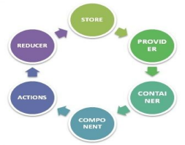

STORE − Stores all your application state as a JavaScript object PROVIDER − Makes stores available

CONTAINER − Get apps state & provide it as a prop to components COMPONENT − User interacts through view component

ACTIONS − Causes a change in store, it may or may not change the state of your app

REDUCER − Only way to change app state, accept state and action, and return updated state.

However, Redux is an independent library and can be used with any UI layer. React-redux is the official Redux, UI binding with the react. Moreover, it encourages a good react Redux app structure. React-redux internally implements performance optimization, so that component re-render occurs only when it is needed.

To sum up, Redux is not designed to write the shortest and fastest code. It is intended to provide a predictable state management container. It helps us understand when a certain state changed, or where the data came from.

19

**HARDWARE REQUIREMENTS AND**

**SOFTWARE USED**

Hardware Requirements:

● RAM:- 4.00GB ·

● Processor:- Intel(R)Core(TM) i3-4005U CPU @ 1.70GHz

Software Used :

● VSCode text editor for creating API. ·

● Insomnia Designer for handling and testing http requests

● Chrome and Edge Browsers for testing

● React and Redux DevTools Extensions for Chrome and Edge

● Node js for hosting server on localhost .

● RoboMongo 3T for visual representation of Database

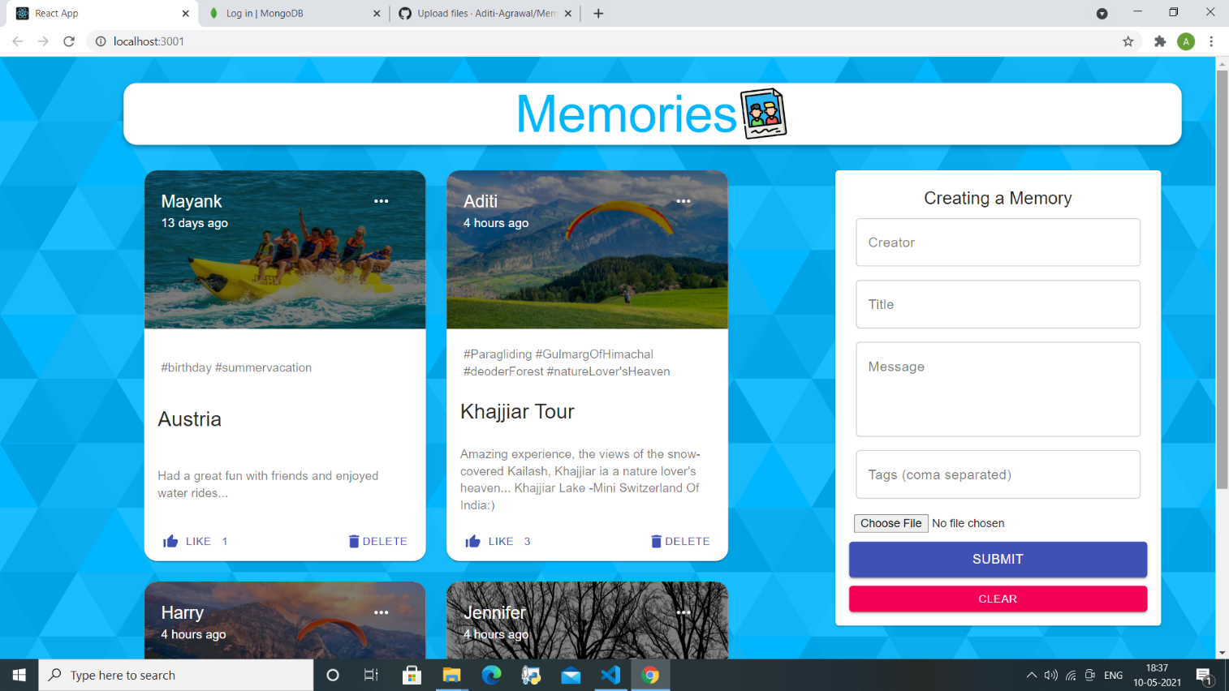 **SUMMARY OF MODULES/PAGES**

This is our login page in which users will login using their credentials. If user has not registered earlier then they can sign up by clicking on register me. Then a sign up page will appear.

The image shown below shows the functionality that by clicking on load more it will show us more options.

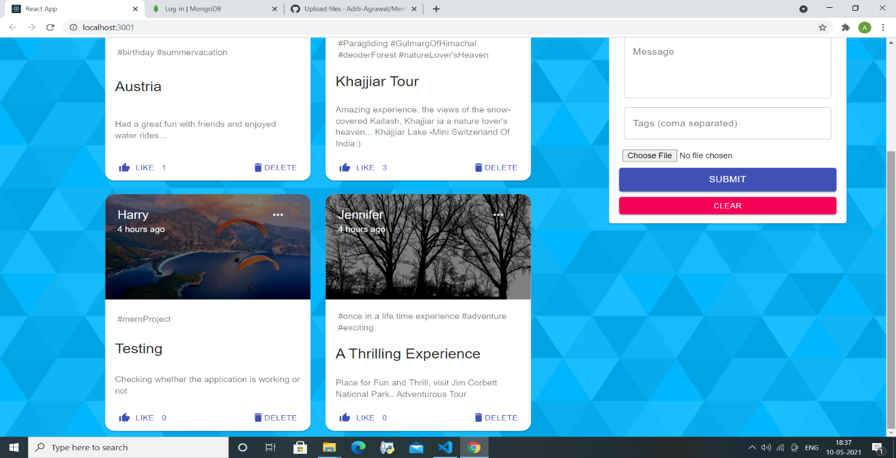

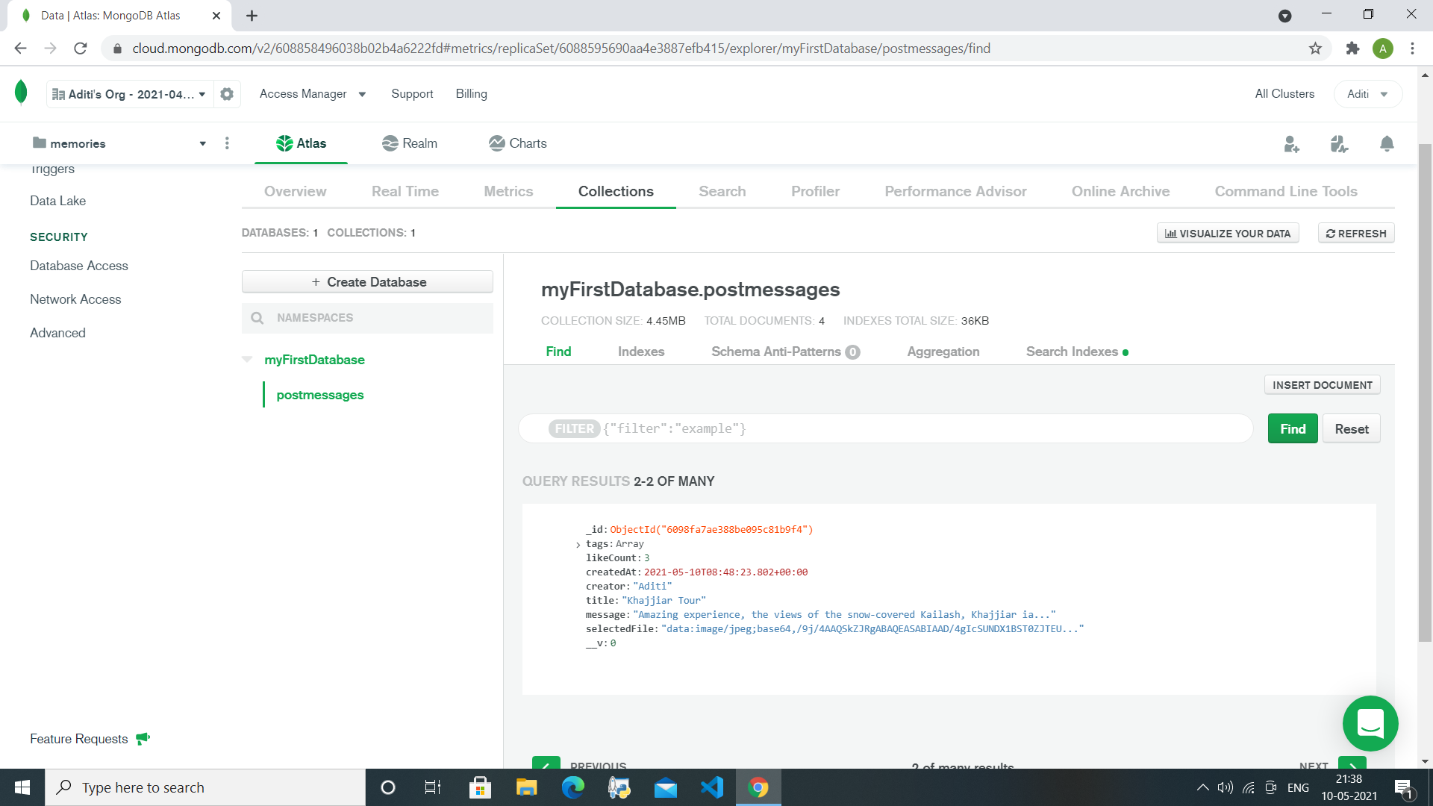

Now here are some snippets of the database in which our data is going to store as shown below.

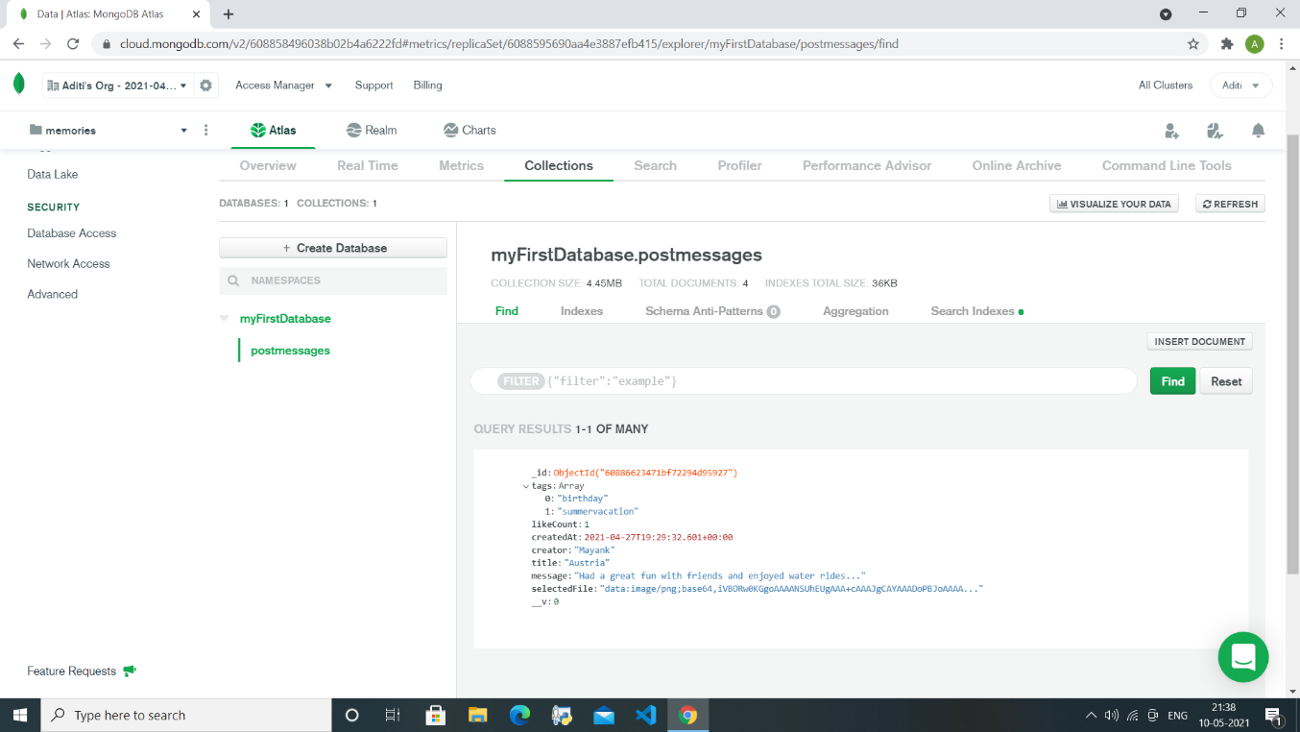

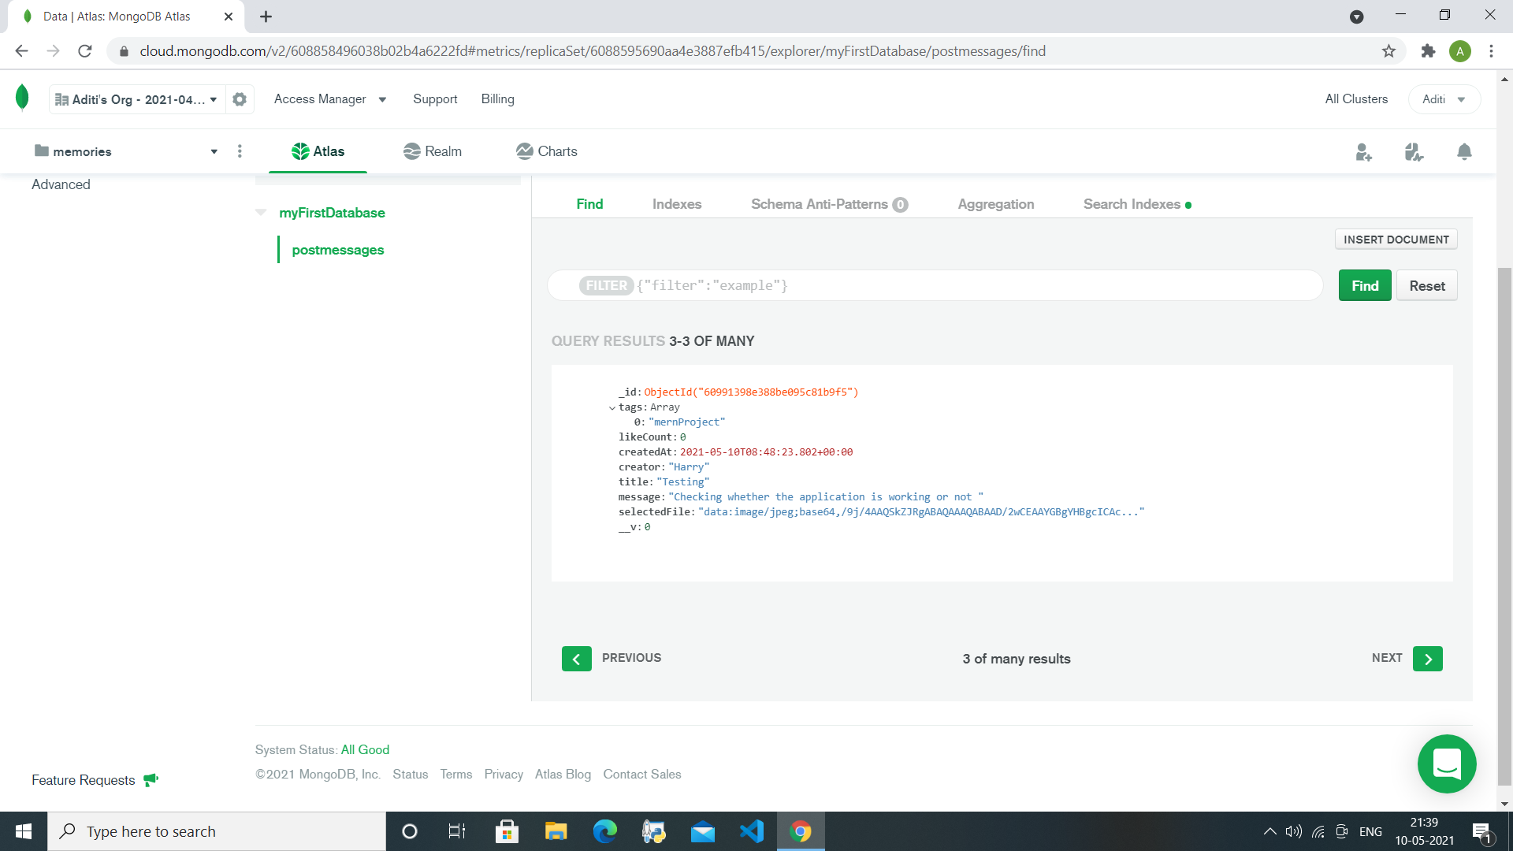

**References**

**● https://www.geeksforgeeks.org/mern-stack/**

**● https://docs.mongodb.com/**

**● http://expressjs.com/**

**● https://reactjs.org/**

**● https://nodejs.org/**

**● https://socket.io/get-started/**

**● https://learnredux.com/**

**● https://www.tutorialspoint.com/redux/index.htm**

**THANK YOU**